Meeting Minutes 20.12.24
LTSpice Simulations:
DC Transient Simulation – looking at what the “steady state” of the system looks like
- Transient time period can set to like 0.1 sec or 1 sec, the rest leave blank

- Can use this to set different voltage levels of voltage sources and see component characteristics such as Gain, Biases etc.
- Until now I have been testing with 2.5V input (from the current transducer)
  - But this is the upper limit. Test for different voltages as well – because the 2.5V is on the upper limit so we may not be able to properly see if the circuit is working properly
  - Try with maybe 1V or negative voltages as well
    - LOOK AT CURRENT TRANSDUCER and the current levels of it – in the data sheet
AC Simulation
- AC Sweep small signal analysis: based on the constant DC Signal we do a small perp
  - Only is recording the AC signals
  - That is why I was getting 0.8V – it was when the original current transducer input is 2.5V, but the voltage bias voltage source is 0V.
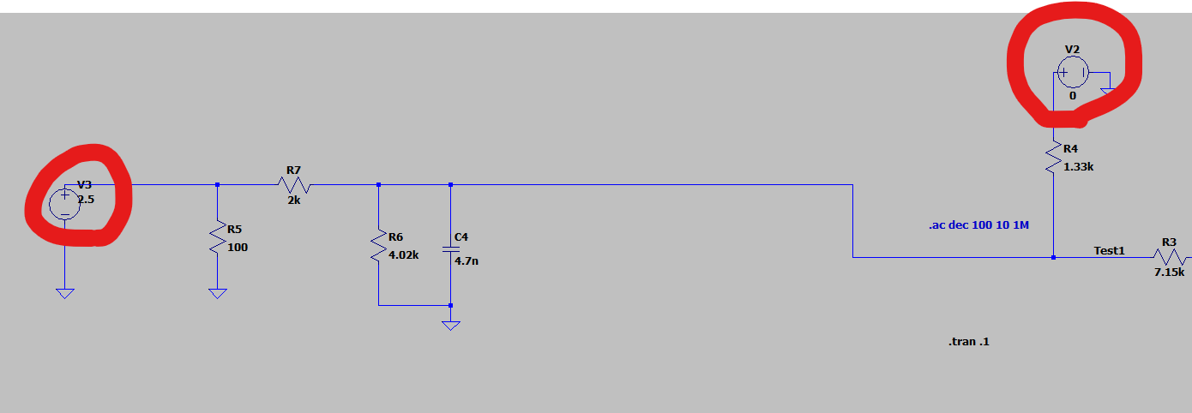
- Need to think again about why the 2.5V becomes 0.8 instead of 1.65 by the voltage divider
  - This means that the 0V is bringing it down somehow. The voltage divider formed by V2 -> but if this source is zero
    - How does this work??
    - It is not 2.5V, it should’ve been a current source that sets the voltage level of around 2.458V due to R5

The 3.3V should introduce a Bias to the system
- If we start at the 3.3V input source, there is a voltage divider: the RC Filter on the left can be added together for resistance Z and then after the 3.3V there is also a resistor. They are similar in resistance so the output we have is increased by 1.65V.
  - Original signal voltage is increased by 1.65V -> Bias of 1.65V exists on the signal from here on.
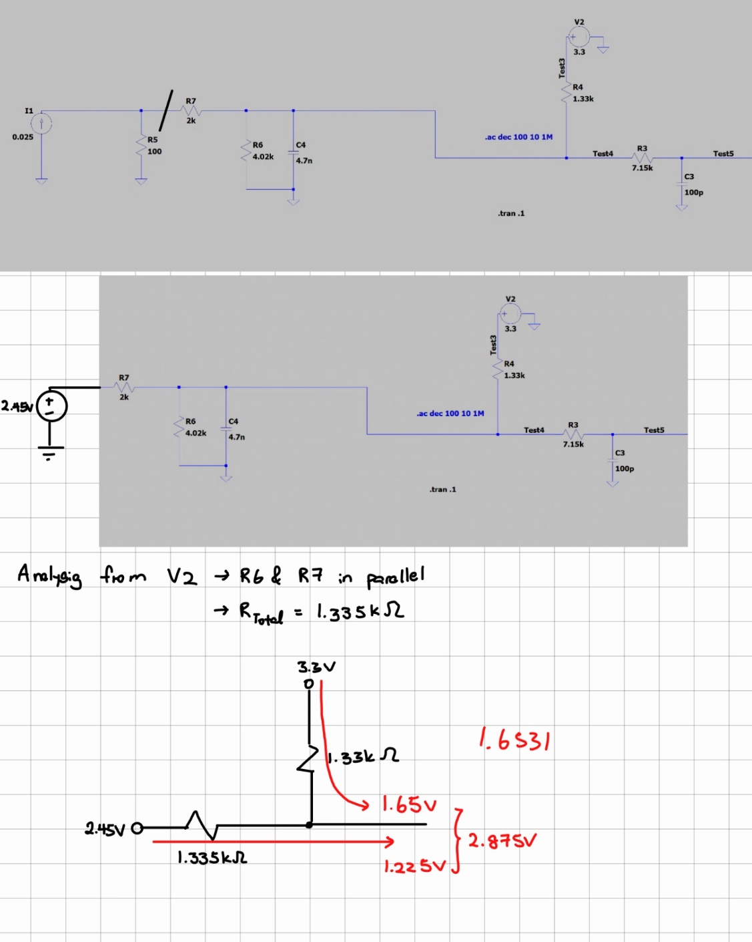
I understand the 1.65V Bias now.
Question: In LTSpice however the resulting Voltage Level is not 2.87 but 2.48 – Where does the 400mV difference come from? – Probably because the 2.875V were not correctly calculated. Cannot use the Knotensummenregel for Voltages
- Because of C4?

https://bitbucket.org/ultrazohm/uz_a_ltc2311-16/ -> someone already simulated with the THS4561 or whatever the name of our fully differential op-amp is
- Both the symbol and LTSpice simulation are available
For fully differential Op Amp
- Understand the need for the external voltage for the inverting input
- See if it is also okay if we directly put the 2.5V, not including the resistor in series
When importing Altium Files -> “Extract All” instead of “Import”

Altium PCB
- Consider using one of the Ultrazohm cards as the pcb outline instead of deisigning one from scratch
  - But keep in mind the Befestigungspunkt to prevent the card from wobbling too much

Current Transducer:
Converts a primary current (current we want to measure) into a usable low-voltage or low-current signal on the secondary side. Secondary signal is proportional to the primary current, allowing it to be monitored.
- Hall-Effect Sensing
- With LAH-50P Current Transducer:
  - Turns Ratio of 1:2000
  - Primary current is scaled down by 2000
    - Then through the I to V converter, the small current is translated into a voltage level
I to V converter
- Ohms Law, uses the pull down resistor – 100 Ohms
  - The rest of the circuit is connected in parallel so the 100 Ohm resistor sets the voltage level for the coming part of the circuit.
Without connecting T-to-V Converter to Current Conditioning
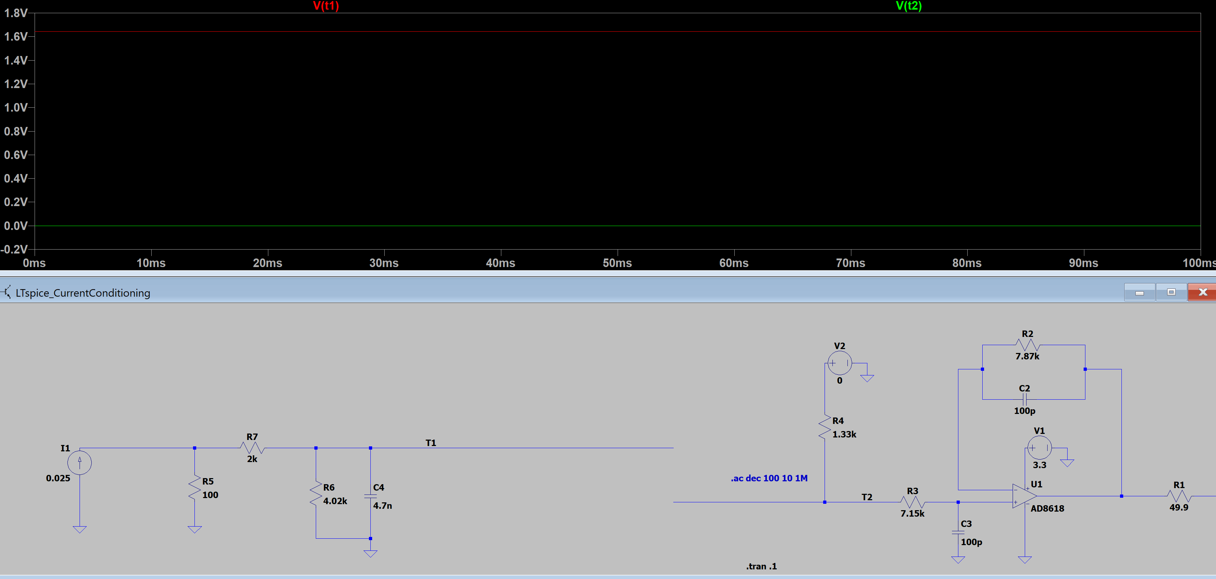
Voltage at T1: 1.64V
Voltage at T2: -66.5pV
- Why does voltage at T2 appear?
  - Tiny current of 50fA is still being pulled from the voltage source V2
  - Due to R4 there is a tiny voltage of -66.5V
    - NOT DUE to R4 – it is due to the Op-Amp
- Why is the Voltage at T2 negative?

A current transducer (often called a current sensor) is a device that converts a primary current (the current you want to measure) into a usable low-voltage or low-current signal on the secondary side. This measurement signal is proportional to the primary current, allowing it to be monitored or recorded by control systems or meters.

